
CosmiCode
Artificial Intelligence
Internship Module
Week 4: Machine Learning Basics for AI (Intermediate to Advanced)

Submitted To: Zarwish – CosmiCode HR
Submitted By: Haris Ali
Subject: Artificial Intelligence
Internship Module: Week 4
Date of Submission: 02/07/2025

Objective: Learn basics of Machine Learning, a core AI branch.
TASK 1:
Install Scikit-Learn and load a dataset (e.g., Iris dataset).
SOLUTION:
First I install the required libraries then I make a code,
from sklearn.datasets import load_iris
import pandas as pd

iris = load_iris()
df = pd.DataFrame(data=iris.data, columns=iris.feature_names)
df['target'] = iris.target
print(df.head())
OUTPUT:
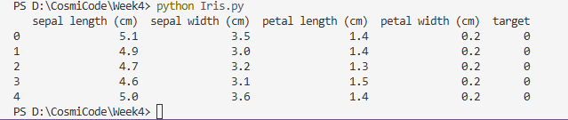

TASK 2:
Perform data preprocessing: handling missing values and encoding categorical data.
SOLUTION:
from sklearn.datasets import load_iris
import pandas as pd
import numpy as np

iris = load_iris()
df = pd.DataFrame(data=iris.data, columns=iris.feature_names)
df['target'] = iris.target

print("First 5 rows of dataset:")
print(df.head())

print("\nMissing values before simulation:")
print(df.isnull().sum())

df.loc[0, 'sepal length (cm)'] = np.nan
print("\nMissing values after introducing NaN:")
print(df.isnull().sum())
df['sepal length (cm)'].fillna(df['sepal length (cm)'].mean(), inplace=True)
print("\nMissing values after filling with mean:")
print(df.isnull().sum())
print("\nFinal dataset preview after preprocessing:")
print(df.head())

OUTPUT:
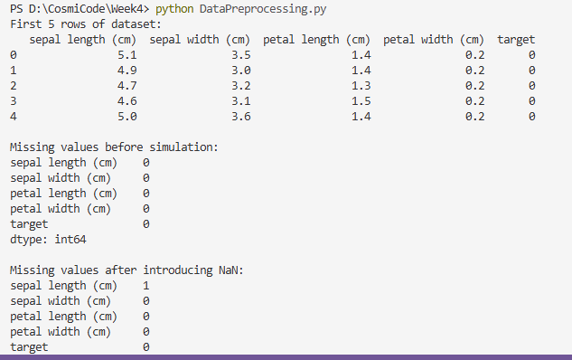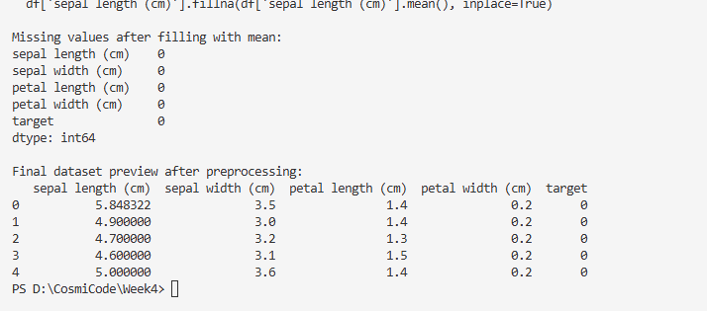
TASK 3:
Implement Linear Regression on a dataset and visualize the result.
SOLUTION:
import pandas as pd
import numpy as np
import matplotlib.pyplot as plt
from sklearn.datasets import load_iris
from sklearn.linear_model import LinearRegression

iris = load_iris()
df = pd.DataFrame(data=iris.data, columns=iris.feature_names)
df['target'] = iris.target

df.fillna(df.mean(), inplace=True)

X = df[['sepal length (cm)']] # Independent variable
y = df['petal length (cm)'] # Dependent variable

model = LinearRegression()
model.fit(X, y)

y_pred = model.predict(X)

plt.figure(figsize=(8,6))
plt.scatter(X, y, color='blue', label='Actual Data')
plt.plot(X, y_pred, color='red', linewidth=2, label='Regression Line')
plt.xlabel('Sepal Length (cm)')
plt.ylabel('Petal Length (cm)')
plt.title('Linear Regression: Sepal Length vs Petal Length')
plt.legend()
plt.grid(True)
plt.show()

print(f"Model Coefficient (Slope): {model.coef_[0]:.4f}")
print(f"Model Intercept: {model.intercept_:.4f}")

OUTPUT:
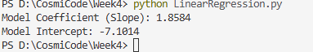
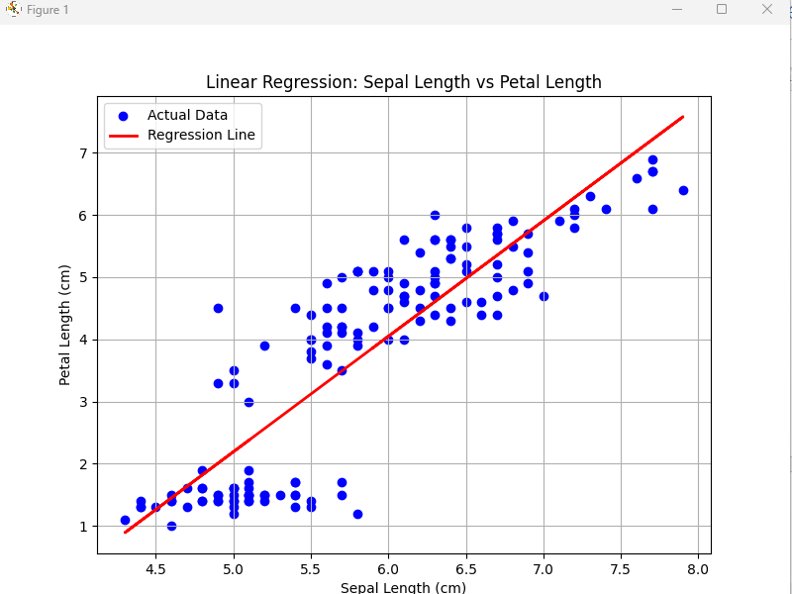
TASK 4:
Implement K-Nearest Neighbors (KNN) on the Iris dataset and evaluate accuracy.
SOLUTION:
import pandas as pd
import numpy as np
from sklearn.datasets import load_iris
from sklearn.neighbors import KNeighborsClassifier
from sklearn.model_selection import train_test_split
from sklearn.metrics import accuracy_score

iris = load_iris()
df = pd.DataFrame(data=iris.data, columns=iris.feature_names)
df['target'] = iris.target

df.fillna(df.mean(), inplace=True)

X = df.iloc[:, :-1] # All columns except target
y = df['target'] # Target column

X_train, X_test, y_train, y_test = train_test_split(X, y, test_size=0.3, random_state=42)

knn = KNeighborsClassifier(n_neighbors=5)
knn.fit(X_train, y_train)

y_pred = knn.predict(X_test)

accuracy = accuracy_score(y_test, y_pred)
print(f"KNN Classifier Accuracy: {accuracy * 100:.2f}%")

OUTPUT:
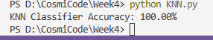

TASK 5:
Implement Decision Tree Classifier and visualize it using Graphviz or Matplotlib.
SOLUTION:
import pandas as pd
import numpy as np
import matplotlib.pyplot as plt
from sklearn.datasets import load_iris
from sklearn.tree import DecisionTreeClassifier, plot_tree
from sklearn.model_selection import train_test_split
from sklearn.metrics import accuracy_score

iris = load_iris()
df = pd.DataFrame(data=iris.data, columns=iris.feature_names)
df['target'] = iris.target

df.fillna(df.mean(), inplace=True)

X = df.iloc[:, :-1]
y = df['target']

X_train, X_test, y_train, y_test = train_test_split(X, y, test_size=0.3, random_state=42)

dt = DecisionTreeClassifier(random_state=42)
dt.fit(X_train, y_train)

y_pred = dt.predict(X_test)

accuracy = accuracy_score(y_test, y_pred)
print(f"Decision Tree Classifier Accuracy: {accuracy * 100:.2f}%")

plt.figure(figsize=(15, 10))
plot_tree(dt,
feature_names=iris.feature_names,
class_names=iris.target_names,
filled=True,
rounded=True,
fontsize=10)
plt.title("Decision Tree Visualization - Iris Dataset")
plt.show()

OUTPUT:
